1. **DATA DICTONARY :**

A Data Dictionary is a collection of names, definitions, and attributes about data elements that are being used or captured in a database, information system, or part of a research project. It describes the meanings and purposes of data elements within the context of a project, and provides guidance on interpretation, accepted meanings and representation. A Data Dictionary also provides metadata about data elements. The metadata included in a Data Dictionary can assist in defining the scope and characteristics of data elements, as well the rules for their usage and application.

**Why Data Dictionary is Important :**

* The main reason companies use data dictionaries is to document and share data structures and other information for all involved with a project or database.
* Using a shared dictionary ensures the same quality, meaning, and relevance for all data elements for all team members.
* The data dictionary will define conventions for the project and consistency throughout the dataset.
  + - Without a data dictionary, there’s a higher risk of losing crucial information in translation and transition. Using a data dictionary also helps teams analyse the data easier later on.
* **DATABASE DESIGN**

**D**ataBase **N**ame **: ehealthcare**

1. **Table Name :** patient

This Table Is Used to Store Information of Patient In System. This table Is Use When Any Patient Want to Book His/her Appointment.

|  |  |  |  |  |  |
| --- | --- | --- | --- | --- | --- |
| Sr.no | Field Name | Data Type | Size | Constraint | Description |
| 1 | patient_id | Int | 3 | Primary Key, Auto Increment | Use To Store Unique Id Of Each Patient |
| 2 | patient_email | Varchar | 25 | Not Null,  Unique Key | Use To Store Email Address Of Patient |
| 3 | patient_name | Varchar | 15 | Not Null | Use To Store Name Of Patient |
| 4 | patient_gender | Varchar | 6 | Not Null | Use to Store Gender Of Patient |
| 5 | patient_password | Varchar | 8 | Not Null | Use To Store Password Of Patient with that Patient Login |
| 6 | patient_address | Varchar | 50 | Not Null | Use To Store Address Of Patient |
| 7 | patient_dob | Date |  | Not Null | Use To Store Date Of Birth Of Each Patient |
| 8 | patient_phoneno | Varchar | 12 | Not Null,  Unique key | Use To Store Mobile Number Of Patient |

1. **Table Name :** appointment

This Table Is use to store the appointments Detail. This Table information Is Visible for Admin and particular doctor according to his schedule and also visible to patients for his/her appointments.

|  |  |  |  |  |  |
| --- | --- | --- | --- | --- | --- |
| Sr.no | Field Name | Data Type | Size | Constraint | Description |
| 1 | appo_id | Int | 3 | Primary Key, Auto Increment | Use To Store Unique Id Of Appointments |
| 2 | patient_id | Int | 3 | References (patient table) | Use To Store Patient Id That Reference From patient Table |
| 3 | appo_no | Int | 3 | Not Null | Use To Store Which No Of appointment is Book for This patient |
| 4 | sche_id | Int | 3 | References (schedule table) | Use To Store schedule Id That Reference From schedule Table |
| 5 | appo_date | Date |  | Not Null | Use To Store Date Of Appointment |

1. **Table Name :**pending

This Table Is Use TO Store Pending Request Of Doctor Who Want to Join This System For Making Session And giving consultation to patients from their appointments.

|  |  |  |  |  |  |
| --- | --- | --- | --- | --- | --- |
| Sr.no | Field Name | Data Type | Size | Constraint | Description |
| 1 | pen_doc_id | Int | 3 | Primary Key, Auto Increment | Use To Store Doctor Id |
| 2 | doc_email | Varchar | 25 | Unique Key, Not Null | Use to store doctor email |
| 3 | doc_name | Varchar | 15 | Not Null | Use To Store Doctor’s Name |
| 4 | doc_password | Varchar | 8 | Not Null | Use To Store Doctor’s  Email Password |
| 5 | Doc_gender | Varchar | 6 | Notnull | Use to Store Gender Of Doctor . |
| 6 | doc_phoneno | Varchar | 12 | Unique Key, Not Null | Use To Store Doctor’s  Phone Number |
| 7 | spec_id | Int | 2 | References (specialist table) | Use to Store Doctor’s Specialist |
| 8 | doc_charge | Int | 5 | Not Null | Use TO Store Charge Of Doctor |
| 9 | doc_img | Varchar | 25 | Not null,  Unique Key | Use To Store Path Of Image |

1. **Table Name :**feedback

This Table Is used To Store Information Of Feedback That Give By Patient for Doctor .

|  |  |  |  |  |  |
| --- | --- | --- | --- | --- | --- |
| Sr.no | Field Name | Data Type | Size | Constraint | Description |
| 1 | feedback_id | Int | 3 | Primary Key, Auto Increment | Use To Store Unique Id Of Feedback |
| 2 | doc_id | Int | 3 | References (doctor table) | Use To Store doctor Id That Reference From doctor Table |
| 3 | rate_id | Int | 3 | References (rating table) | Use To Store Rating Id  That reference From rating Table |
| 4 | feedback_description | Varchar | 200 | Not Null | Use To Store The Feedback That Given By Patient |
| 5 | patient_id | Int | 3 | References (patient table) | Use To Store Patient Id That Reference From patient Table |

1. **Table Name :** rating

This Table Is Used To Store Information On Rating Related That How many patient rate the Doctor Or How many Points .

|  |  |  |  |  |  |
| --- | --- | --- | --- | --- | --- |
| Sr.no | Field Name | Data Type | Size | Constraint | Description |
| 1 | rate_id | Int | 3 | Primary Key, Auto Increment | Use To Store Schedule Id |
| 2 | doc_id | Int | 3 | References (doctor table) | Use To Store Doctor Id |
| 3 | rate_total_rating | Int | 4 | Not Null | Use To Store Schedule Title |
| 4 | rate_total_review | Int | 4 | Not Null | Use To Store Schedule Date |

1. **Table Name :** user

This Table Is used When Any User Login In system It check Tyoe Of User And Redirect the reference to According Table On System For login .

|  |  |  |  |  |  |
| --- | --- | --- | --- | --- | --- |
| Sr.no | Field Name | Data Type | Size | Constraint | Description |
| 1 | user_id | Int | 3 | Primary Key, Auto Increment | Use to Store user id |
| 2 | user_email | varchar | 25 | NotNull | Use to Store email id of all system user |
| 3 | user_name | Varchar | 15 | Notnull | Use to store name |
| 3 | user_type | char | 1 | Nonull | Use to Store User Type  [A-Admin,  P-Patient,  D-Doctor] |

1. **DATA FLOW DIAGRAM :**
   * **Notation :**

* The two main types of notation used for data flow diagrams are Yourdon-Coad and Gane-Sarson, both named after their creators, all experts who helped develop DFD methodology: Ed Yourdon, Peter Coad, Chris Gane and Trish Sarson.
* There are some differences in style between the notation types. For example, Yourdon and Coad notation uses circles to represent processes, whereas Gane and Sarson notation use rectangles with rounded corners.
* Because DFD symbols vary, it’s important to be consistent with whatever notation you choose in order to avoid confusion.
* Here we will be using the Yourdon-Coad notations.
* All data flow diagrams include four main elements: entity, process, data store and data flow.
* **Entity :**

**[Entity]**

* + Also known as actors, sources or sinks, and terminators, external entities produce and consume data that flows between the entity and the system being diagrammed.
* **Process :**

**[Process]**

* + An activity that changes or transforms data flows. Since they transform incoming data to outgoing data, all process must have inputs and outputs on a DFD.
  + Processes are typically oriented from top to bottom and left to right on a data flow diagram.
* **Data Source :**

**[Data Source]**

* + A data store does not generate any operations but simply holds data for later access
  + Data stores could consist of files held long term or a batch of documents stored briefly while they wait to be processed.
  + Input flows to a data store include information or operations that change the stored data. Output flows would be data retrieved from the store.
* **Data Flow :**

**[Data Flow]**

* Movement of data between external entities, processes and data stores is represented with an arrow symbol, which indicates the direction of flow.
* Input and output data flows are labelled based on the type of data or its associated process or data store, and this name is written alongside the arrow.

**SYSTEM : E-Health Care Management System**

* + **Level-0 DFD :**

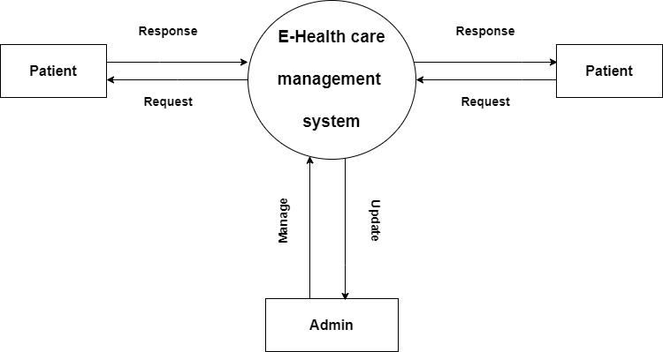

* + **Patient Level – 1 DFD :**

